**Human and Computer Interaction Laboratory**

**Assignment 7**

**Name**: Aditya Kangune **Batch**: K11

**Roll number**: 33323 **Date of Submission**: 24/11/2021

**Email Id:** adityakangs@gmail.com

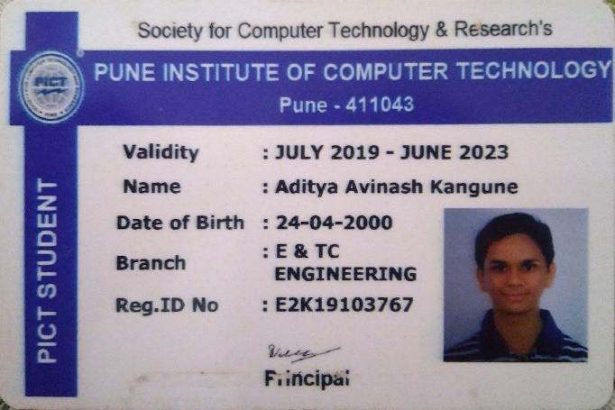

Group Members:

1. Aditya Kangune (33326)

2. Vedant Deshpande (33313)

* **Evaluate UI designed for CMS assignment using Nielsen’s Heuristic evaluation technique. (Given below)**

**Nielsen's heuristics Rules:**

1. **Visibility of system status:**

The visibility of system status refers to how well the state of the system is conveyed to its users. Ideally, systems should always keep users informed about what is going on, through appropriate feedback within reasonable time. The current page of the website is always underlined, thus giving user the necessary feedback for better navigation experience.

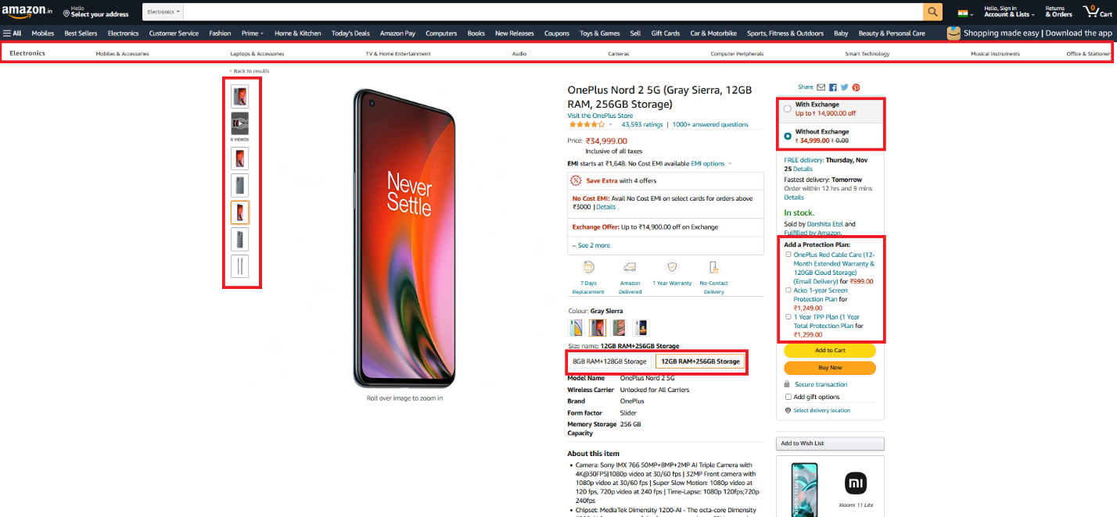

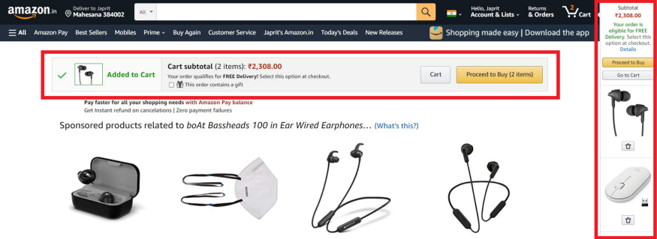

The sidebar on the right and notification on the top is the best way to notify that the user has successfully added an item.

Also when I deleted an item from Sidebar, it is updating as “item is removed from shopping cart” but not updated in the notification.

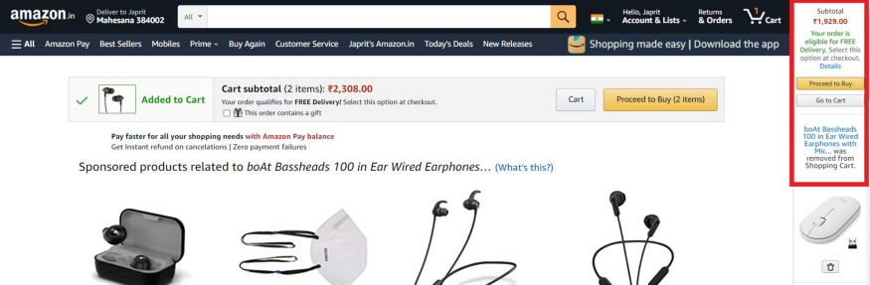

1. **Match between system and the real world:**

The Search Icon in the navigation bar is represented by a magnifying glass. Thus, using the real-world knowledge that magnifying glass symbol generally indicates some form of search action.

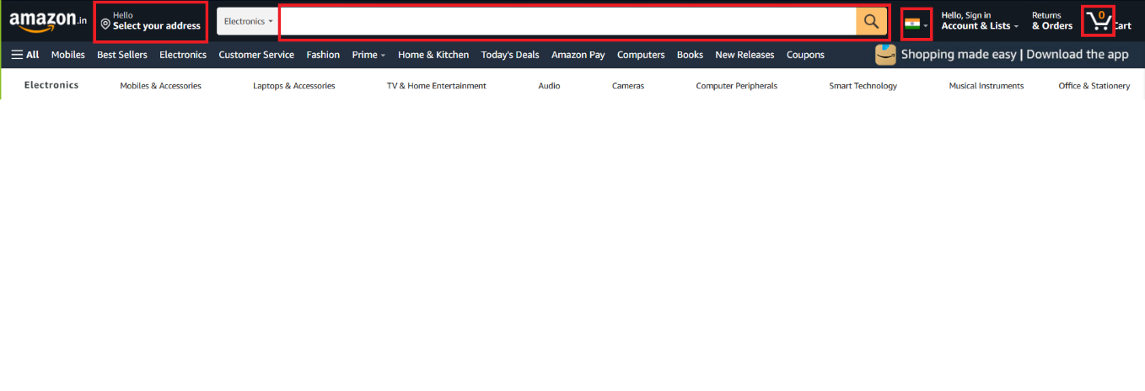

Every icon used in Amazon has direct meaning with its context, no ambiguity.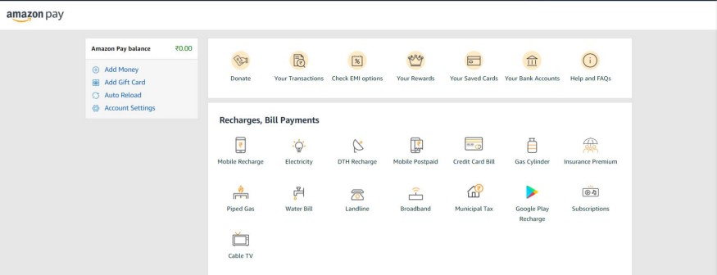

1. **User control and freedom:**

Yes, the user can edit, update and delete the information under the “Account section”.

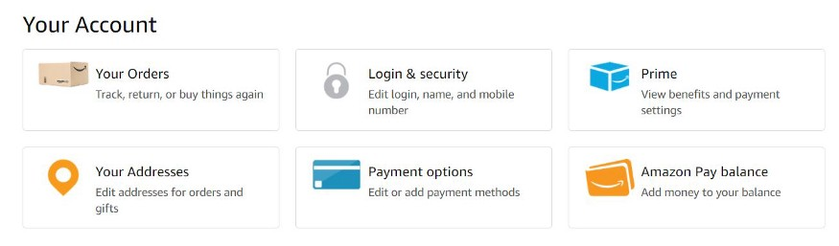

1. **Consistency and standards:**

All the Amazon forms are consistent with colors and Button styles.



1. **Error prevention:**

In Amazon forms, there are labels and placeholders to prevent the user from entering incorrect values. The password validation is guiding the user to at least have 6 digit password.

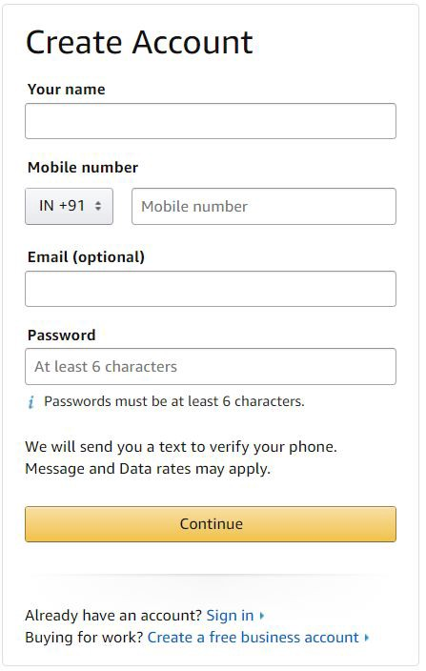

1. **Recognition rather than recall:**

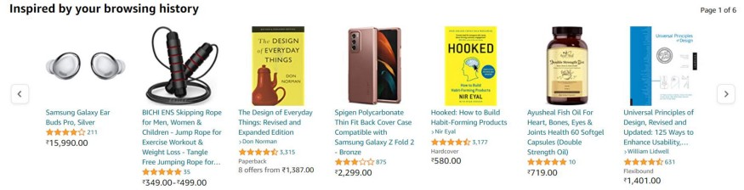

Yes, Amazon provides a section called “Inspired by your browsing history” where all the frequently seen items are shown.

1. **Flexibility and efficiency of use:**

Yes, Amazon provides a section called “Inspired by your browsing history” where all the frequently seen items are shown.

1. **Aesthetic and minimalist design:**

The visual design of Amazon is simple although it is a very complex application for someone who is not tech-savvy, accent colours are used for important information such as validity of stock, sale items, etc.

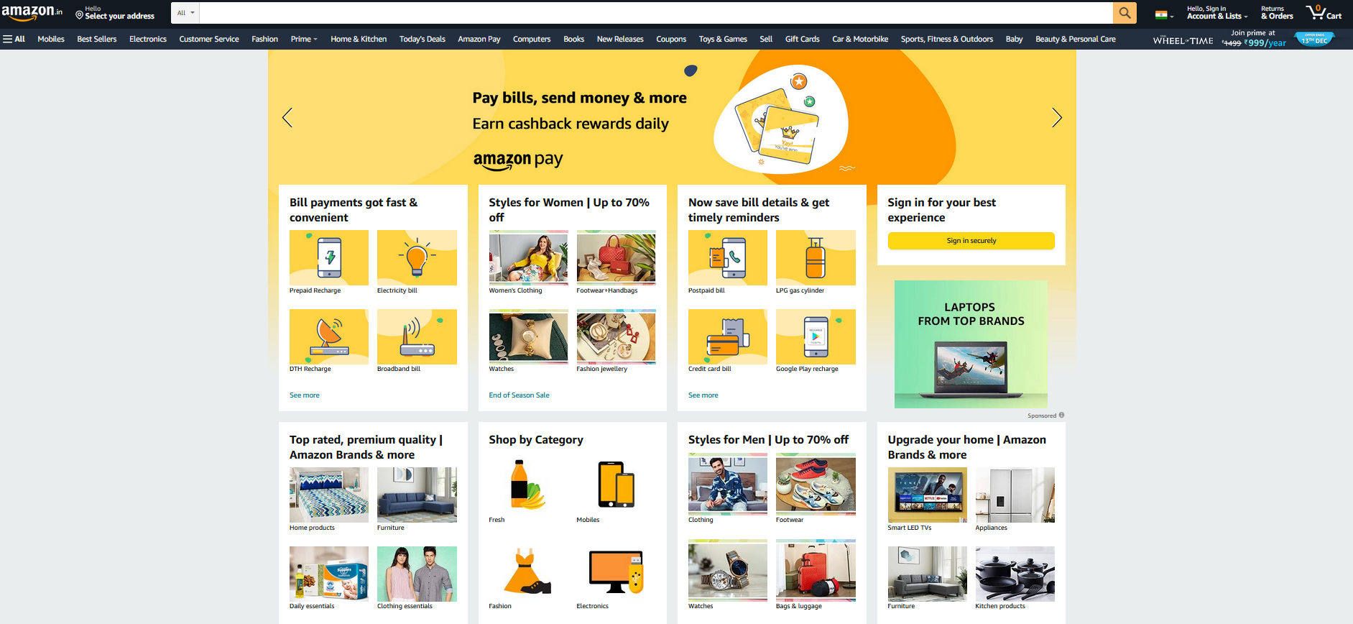

1. **Help users recognize, diagnose, and recover from errors:**

All form fields have validation messages when incorrect information has been entered.

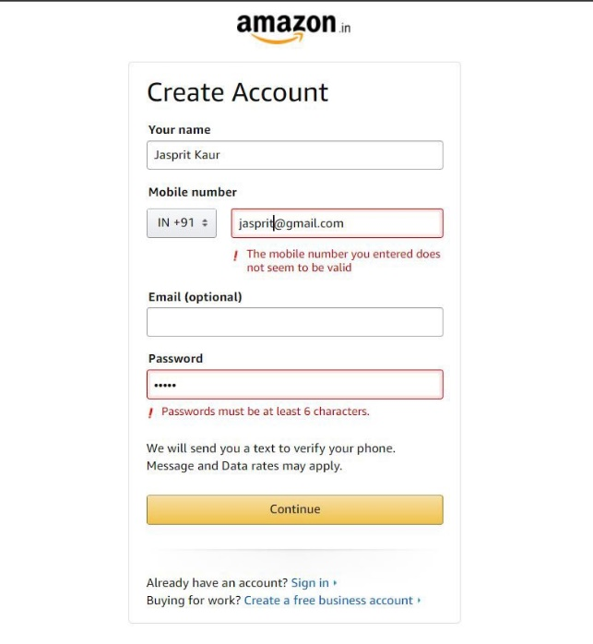

All input fields on the Amazon website have useful descriptions on how to rectify the problem.

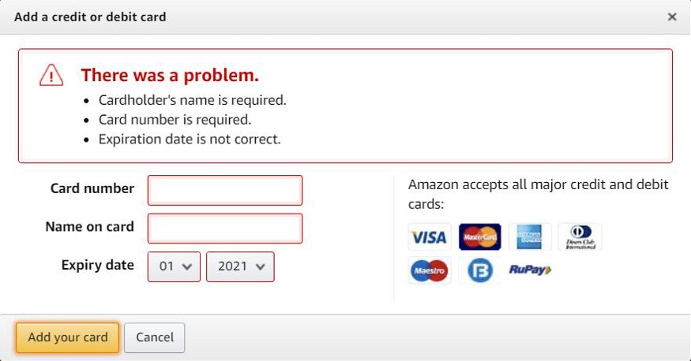

1. **Help and documentation:**

Shopping on the Amazon website is pretty simple, no onboarding or guide is needed to purchase an item. Each page includes clear CTAs to choose colour, change the quantity and add the item to the cart, registry or wish list.

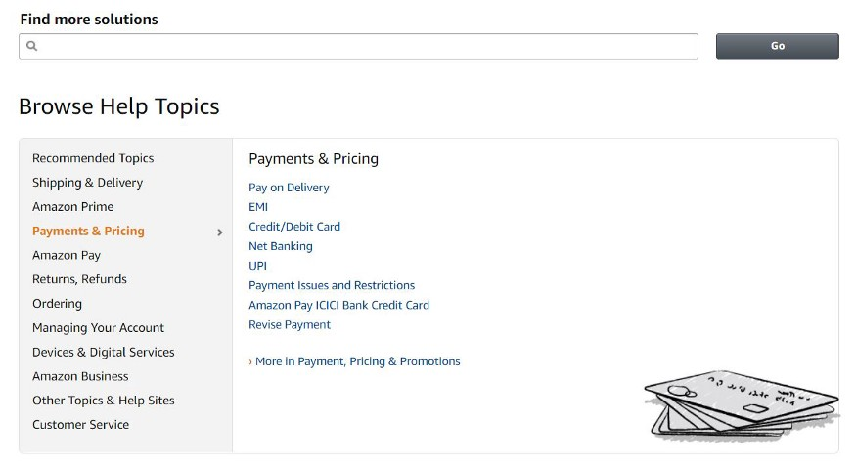

* **Evaluate UI designed for CMS assignment using Nielsen’s Heuristic evaluation technique**

**Shneiderman's Eight Golden Rules of Interface Design**

1. **Strive for Consistency**

* Consistency helps users to achieve their goals and navigate through your app easily. when a UI works consistently, it becomes predictable (in a good way), which means users can understand
* how to use certain functions intuitively and without instruction and as an interface designer you should remember that your user is not using your product only, they are getting ideas, expectations, and building intuition from lots of different products.
* Things can go south very easily and can frustrate our users if our design is inconsistent and not familiar to users. Just imagine having two hamburger menus and a search bar at the bottom or… the “Delete” button highlighted in green.
* As you can see, **Instagram's** design has been consistent from 2009 to 2020, with its Feed Layout style and navbar icons staying consistent.

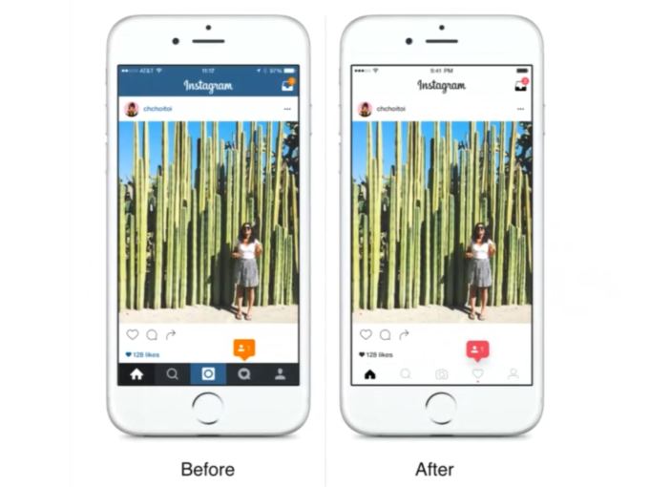

1. **Enable Frequent Users to Use Shortcuts.**

* Recognize the needs of diverse users and design, facilitating the transformation of content. Novice-expert differences, age ranges, disabilities, and technology diversity each enrich the spectrum of requirements that guides design. Adding features for novices, such as explanations, and features for experts, such as shortcuts and faster pacing, can enrich the interface design and improve perceived system quality.
* Let’s see how Instagram helps different types of users according to their experience so they can carry out tasks successfully without any anxiety.
* **For novice or first-time users**, Instagram provides visual cues and instructions to help first-time users as shown in the figure below.

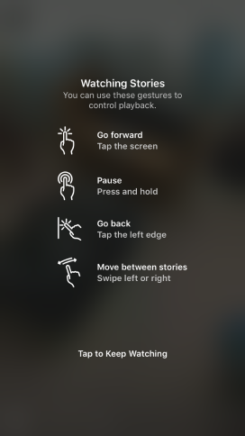

**For experienced or frequent users,** Instagram has this shortcut feature where you press and hold on the profile icon and you can switch between your accounts without even going to the profile page.

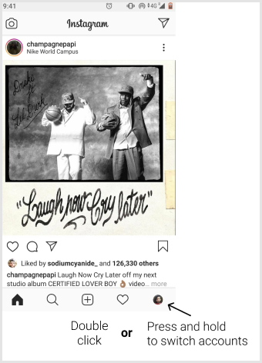

1. **Offer Informative Feedback.**

* For every action, there should be appropriate, human-readable feedback within a reasonable amount of time. So, users can know what is going on.
* For frequent and minor actions, the response can be modest, whereas for infrequent and major actions**.**
* **Example**: Instagram’s double-tap like function gives the user feedback as shown in these pictures



1. **Design Dialog to Yield Closure.**

* Informative feedback after a group of actions gives operators the satisfaction of accomplishment, a sense of relief, the signal to drop contingency plans from their minds, and a signal to prepare for the next group of actions.
* Your user should not spend any time figuring out what is going on, tell them what their action has led them to.
* A classic example would be, e-commerce websites moving users from selecting products to the checkout, ending with a clear confirmation page that completes the transaction.
* **For Example:** On Instagram while uploading any media content.

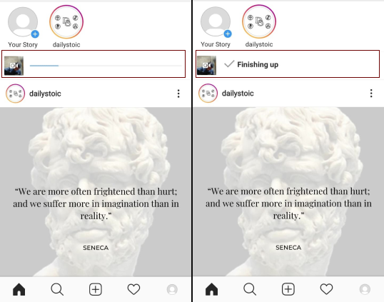

1. **Offer Simple Error Handling.**

* As much as possible, design the system such that users cannot make serious errors; If a user makes an error, the interface should detect the error and offer simple, constructive, and specific instructions for recovery.
* **For example** error message for an incorrect username on the Instagram login page.

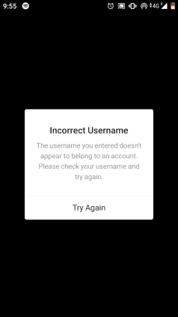

1. **Permit Easy Reversal of Actions.**

* As much as possible, actions should be reversible. This feature relieves anxiety since the user knows that errors can be undone, thus encouraging the exploration of unfamiliar options. The units of reversibility may be a single action, a data-entry task, or a complete group of actions, such as entry of a name and address block.
* Allow your user to undo the action instead of starting over.
* **For example,** the drawing function in Instagram stories provides an undo function.

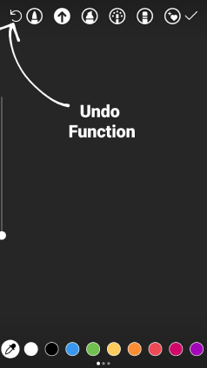

1. **Support Internal Locus of Control.**

* Experienced operators strongly desire the sense that they are in charge of the interface and that the interface responds to their actions. Surprising interface actions, tedious sequences of data entries, inability to obtain or difficulty in obtaining necessary information and inability to produce the action desired all build anxiety and dissatisfaction.
* **Make users the initiators of actions rather than the responders to actions.**

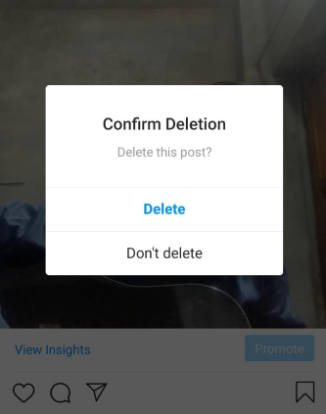

1. **Reduce Short-Term Memory Load.**

* The limitation of human information processing in short-term memory (the rule of thumb is that humans can remember “seven plus or minus two chunks” of information) requires that displays be kept simple.
* Keeping our interface consistent and following the existing guidelines for interface design will help us to make our design more intuitive so our user doesn’t have to recall every time he/she uses the product. It’s simpler for us to recognize information rather than recall it.



You can see in the navigation bar, the “search” icon — which looks like a magnifying glass, the “add” icon — which is made up of the “+” sign. “Home” icon — resembles the real-world home.

All these visual elements are easy to recognize because they resemble real-world things that serve the same purpose.

**Conclusion:** In this assignment, we studied the Nielsen’s Heuristic evaluation technique and Ben Shneiderman’s eight golden rules for interface design. We evaluated websites against these principles.